# Introduction

This task aims in decoding the message which is encoded in an audio signal. The signal can be present at 8 different frequencies in each tone (400, 450, 500, 550, 600, 650, 700, and 750Hz). The 50 ms window is considered at a time and that is considered as a tone. The absence and presence of signal at described frequencies is checked and a binary sequence is formed. This binary sequence is converted into ASCII to decode the hidden message.

# Method

The methodology adopted is isolating 1st 50 ms of audio signal and name it as tome 1. Subsequent tones are created by sequentially considering the 50 ms window hence total 15 tones are formed. FFT of audio signal is taken and the spectrum is plotted to visualize the frequency response of signal. The presence and absence of signal at frequencies 400, 450, 500, 550, 600, 650, 700, and 750Hz is noted and a binary sequence is formed. If the signal is present at certain frequency, 1 is assigned and if no signal is present 0 is assigned. The binary sequence is formed by visualizing the spectrum.

# Results

## First 50 ms (tone 1)

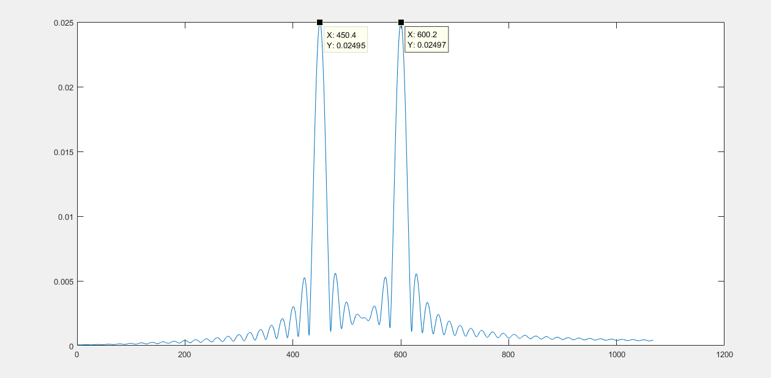

The tone is present at frequency of 450 Hz and 600 Hz in first 50 ms of signal. Therefore, the binary value at these two frequencies is 1 and at remaining frequencies is 0. The binary sequence is 01001000. It is decoded in ASCII character as 72. It represents uppercase letter H.

|  |  |
| --- | --- |
| Frequency (Hz) | Binary digit |
| 400 | 0 |
| 450 | 1 |
| 500 | 0 |
| 550 | 0 |
| 600 | 1 |
| 650 | 0 |
| 700 | 0 |
| 750 | 0 |

Following table represents decoded ASCII character for all 15 tones:

|  |  |  |
| --- | --- | --- |
| Tone number | Binary sequence | Decoded ASCII character |
| Tone 1 | 01001000 | 72 (uppercase H) |
| Tone 2 | 01001000 | 72 (uppercase H) |
| Tone 3 | 01101001 | 105 (lowercase i) |
| Tone 4 | 01111111 | 127 |
| Tone 5 | 00101001 | 41 |
| Tone 6 | 00101111 | 47 |
| Tone 7 | 01101011 | 107 |
| Tone 8 | 00101111 | 47 |
| Tone 9 | 00101111 | 47 |
| Tone 10 | 00111111 | 63 |
| Tone 11 | 00101011 | 43 |
| Tone 12 | 00101011 | 43 |
| Tone 13 | 00101011 | 43 |
| Tone 14 | 00101011 | 43 |
| Tone 15 | 00101011 | 43 |

# Discussion

The task has been completed successfully and the aim of decoding the hidden message in an audio signal has been accomplished. The first tone is decoded has ASCII character 72 which is uppercase H. remaining tones are also decoded as shown in results section. Total 15 tones are decoded.

Total 20 characters are encoded per second.

In 1 second, 20 tones are sent as duration od 1 tone is 0.05.

$$in 0.05 sec=1 tone/character is sent$$

$$in 1 sec=\frac{1}{0.05}=20\frac{tones}{characters}are sent$$

frac_of_1sec=50e-3/1

fifty_ms_sample=frac_of_1sec*fs

total50mstones=length(tone)/fifty_ms_sample

